Task on Load Balancers.*
- Configure Classic Load balancer.*
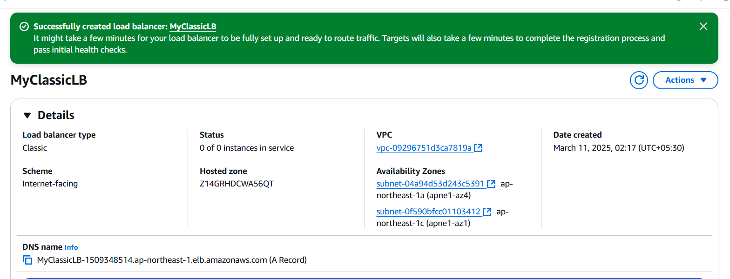

After refreshing the server will be changed ,server 01 and server02
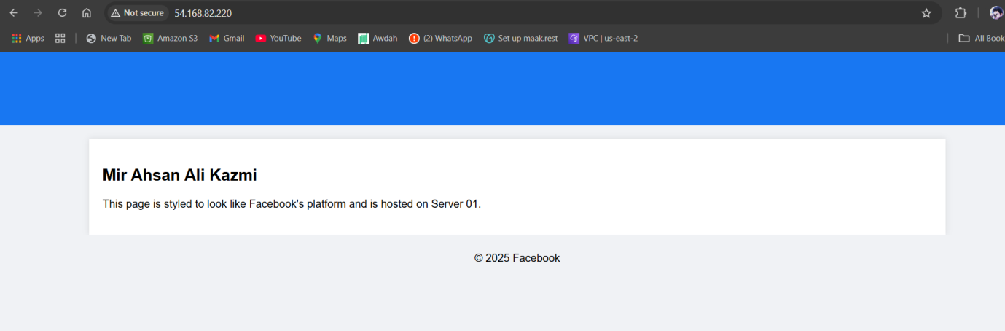
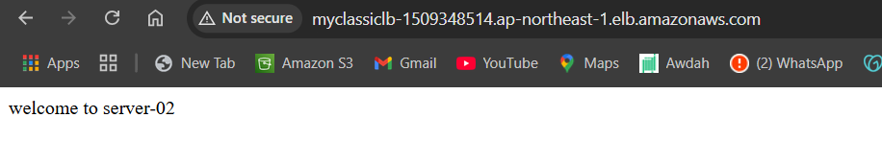
Launch ec2 and install http sever 02 by using script
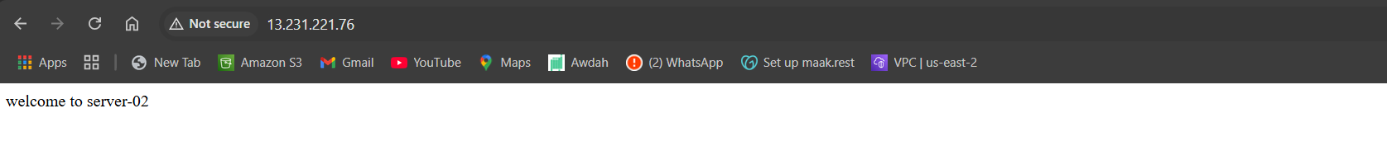

Lauch ec2 server 01 install httpd

Select as a target instances and registered
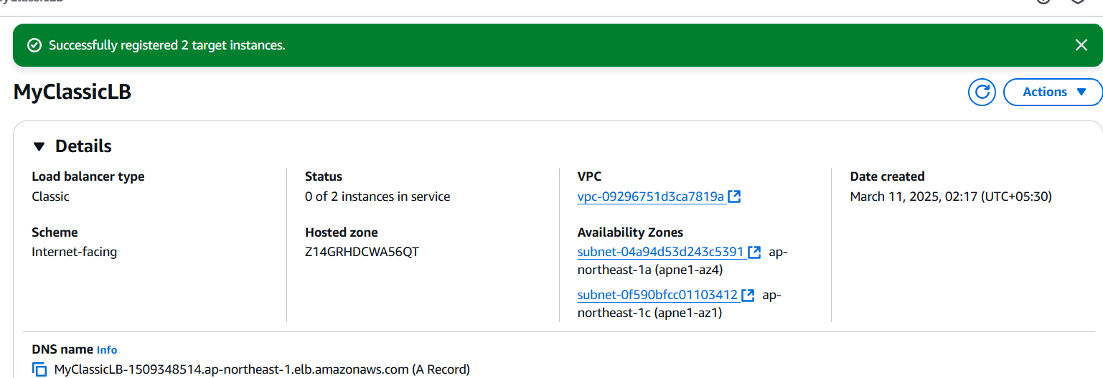
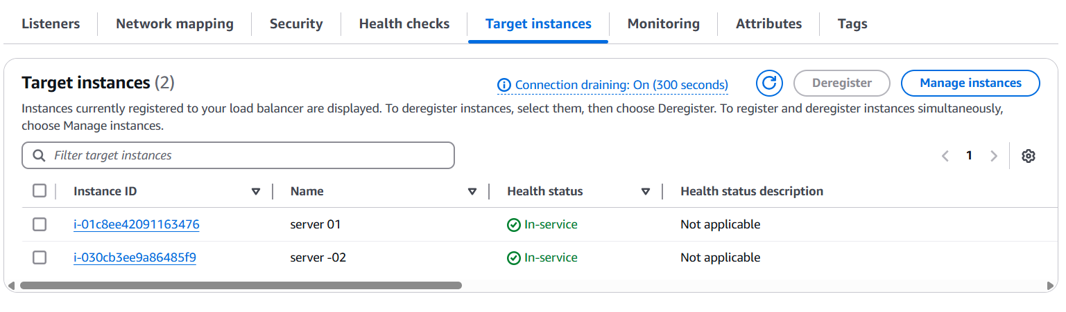
lauch

- Configure Application Load balancer.* 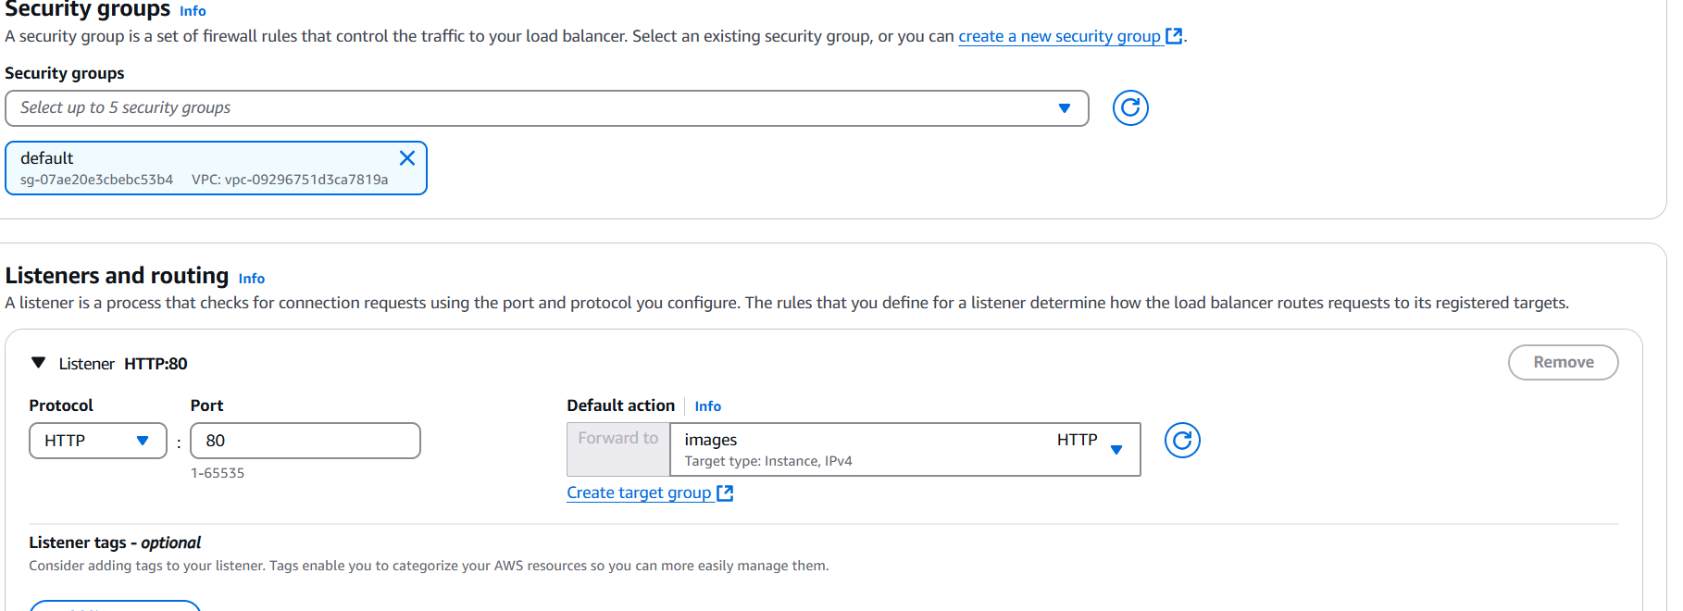
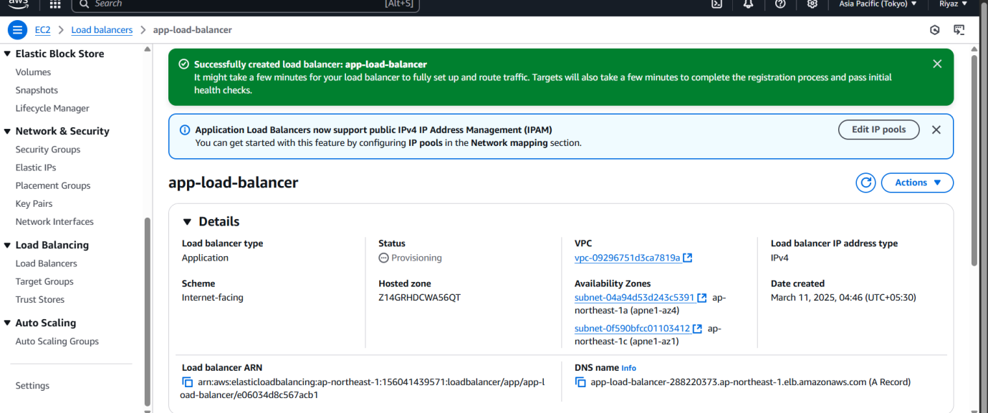

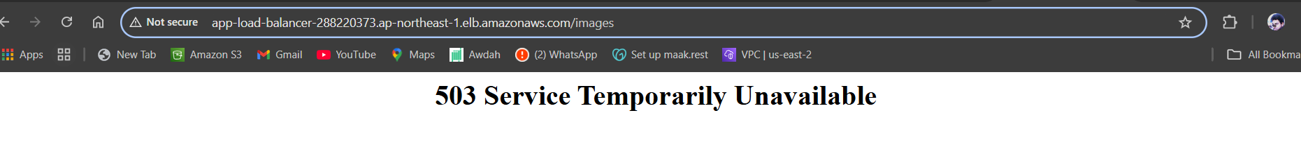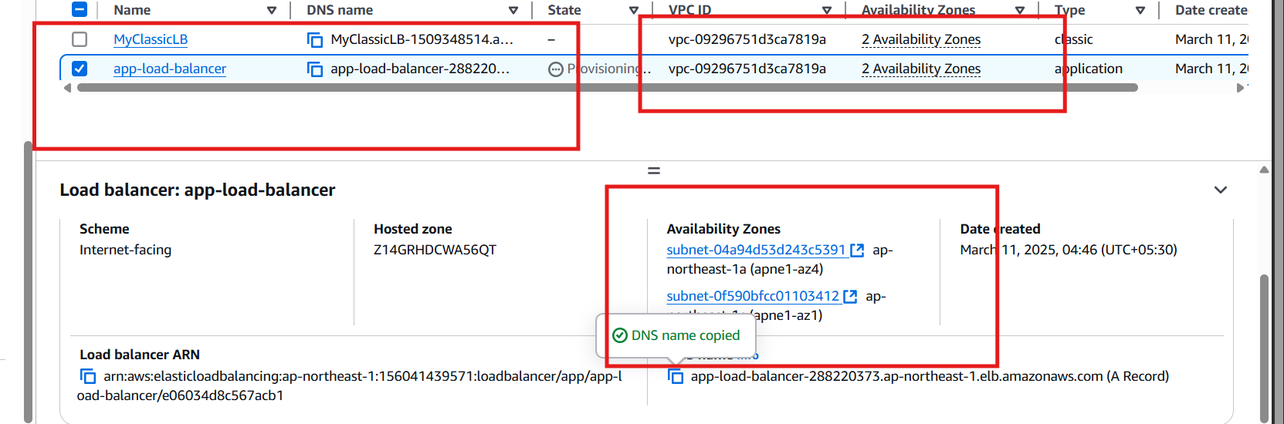

Add listerner and rule 1 and condition and path prefixes
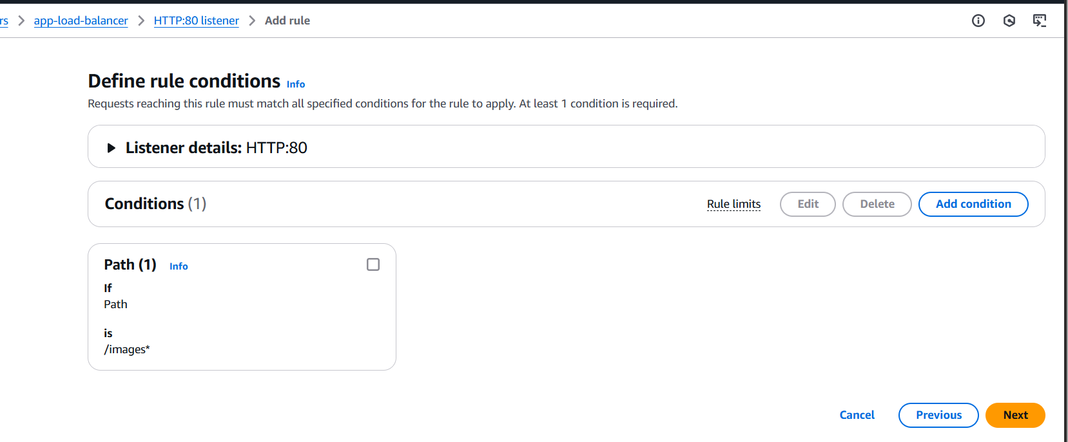

Is uses prefixes images
http://app-load-balancer-288220373.ap-northeast-1.elb.amazonaws.com/images/
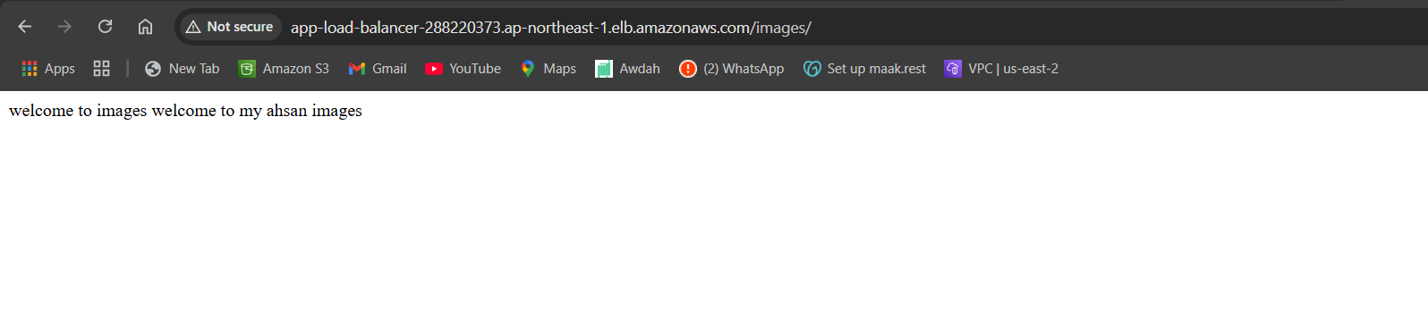
- Configure Network Load balancer.*

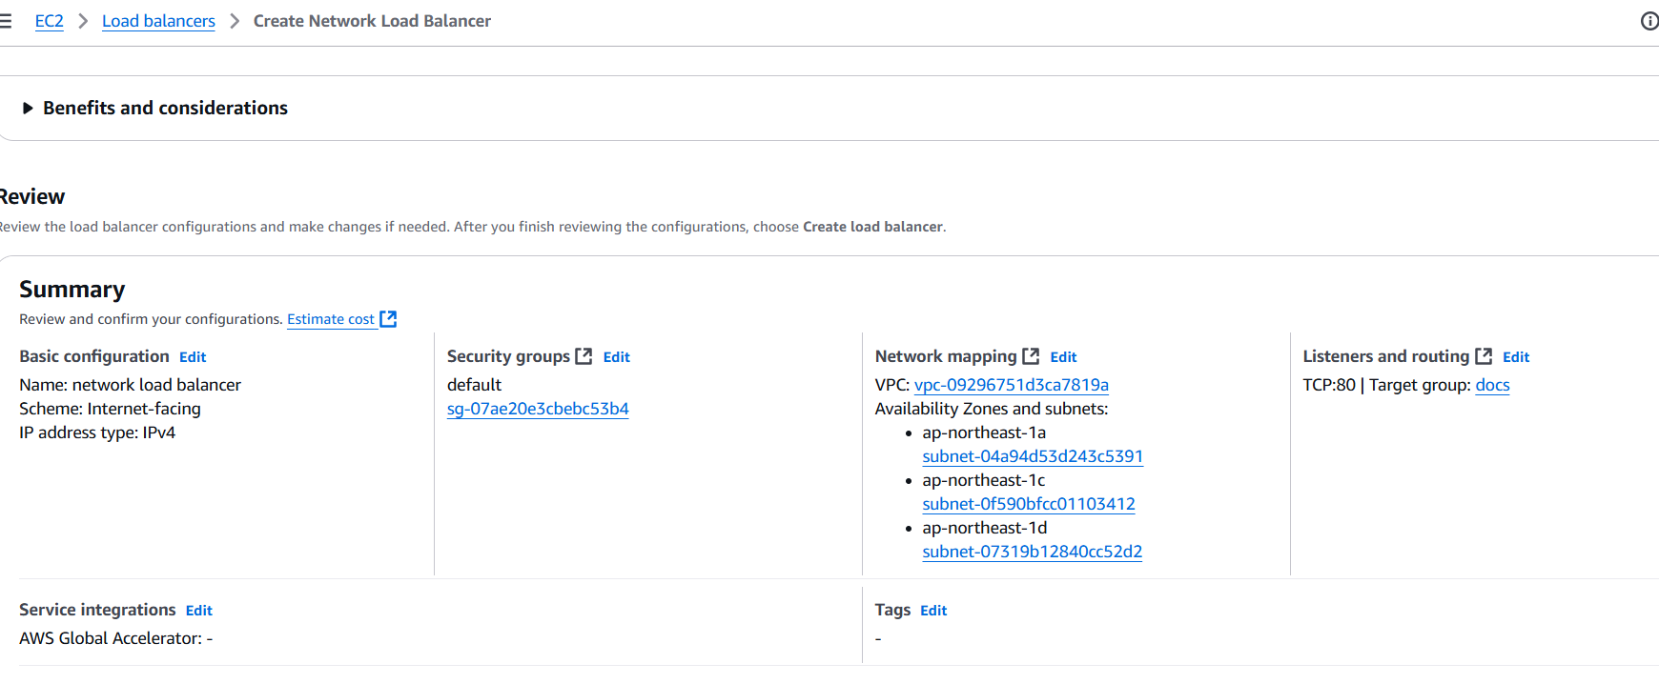

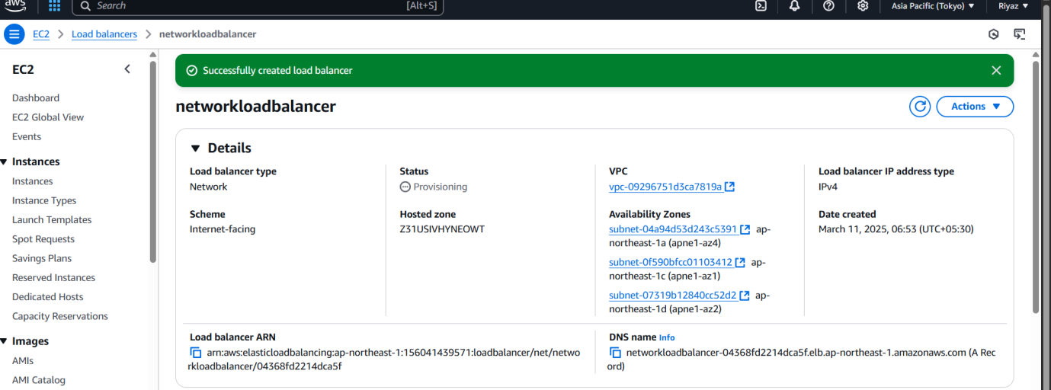

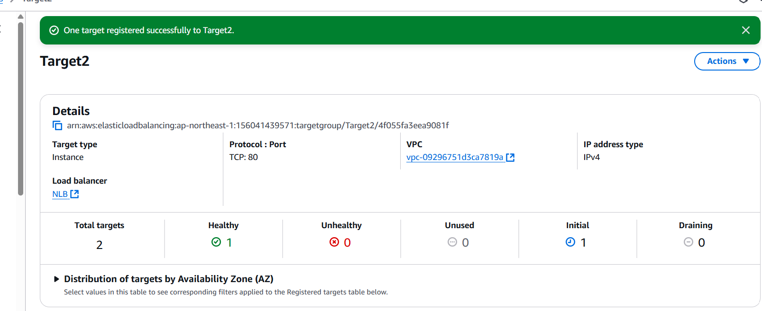
DNS NAME
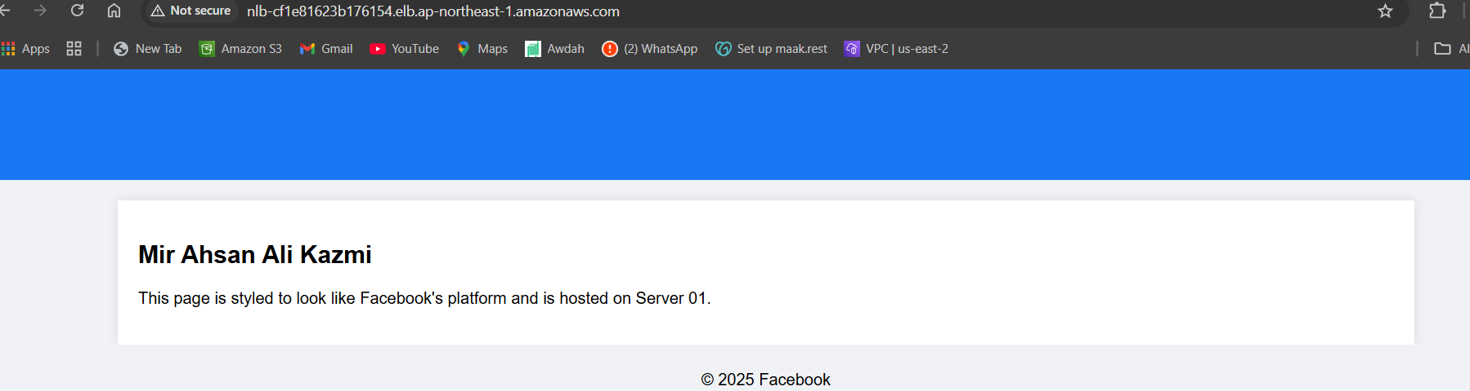

DNS NAME
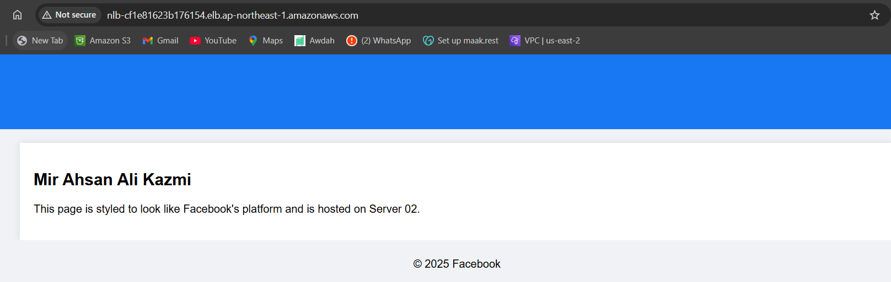

Registry target has been and ec2 in regester to target

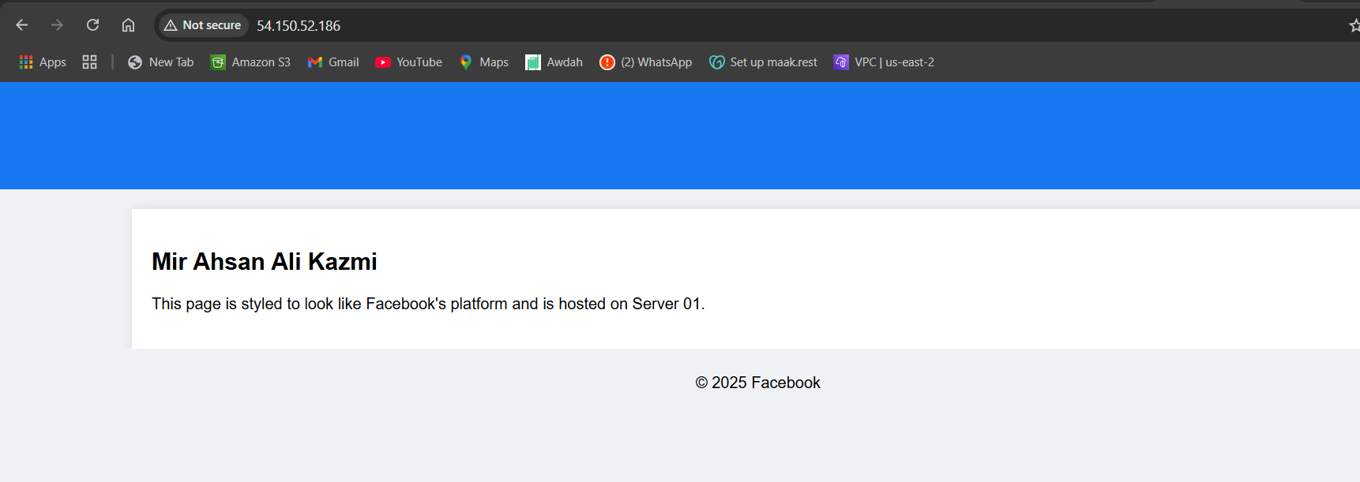
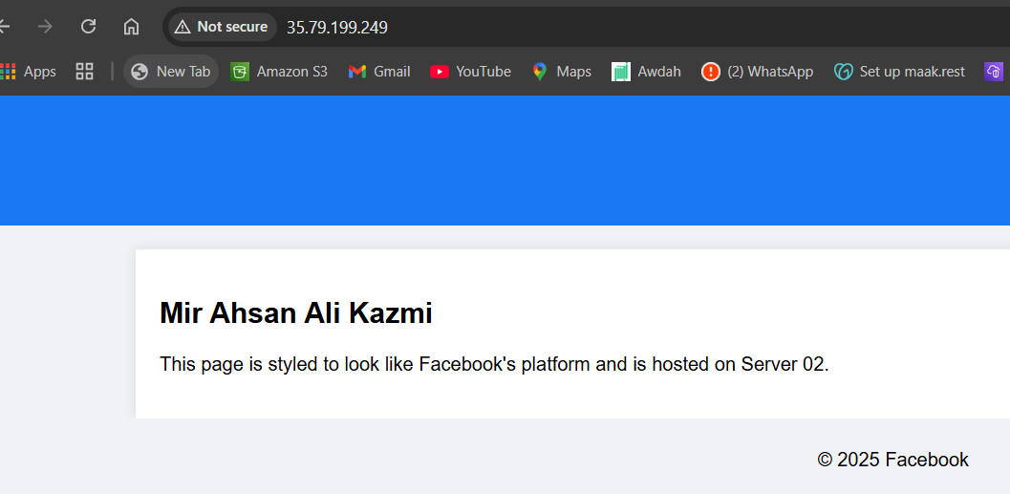
- Attach SSL for application load balancer.*

Ssl certificate created
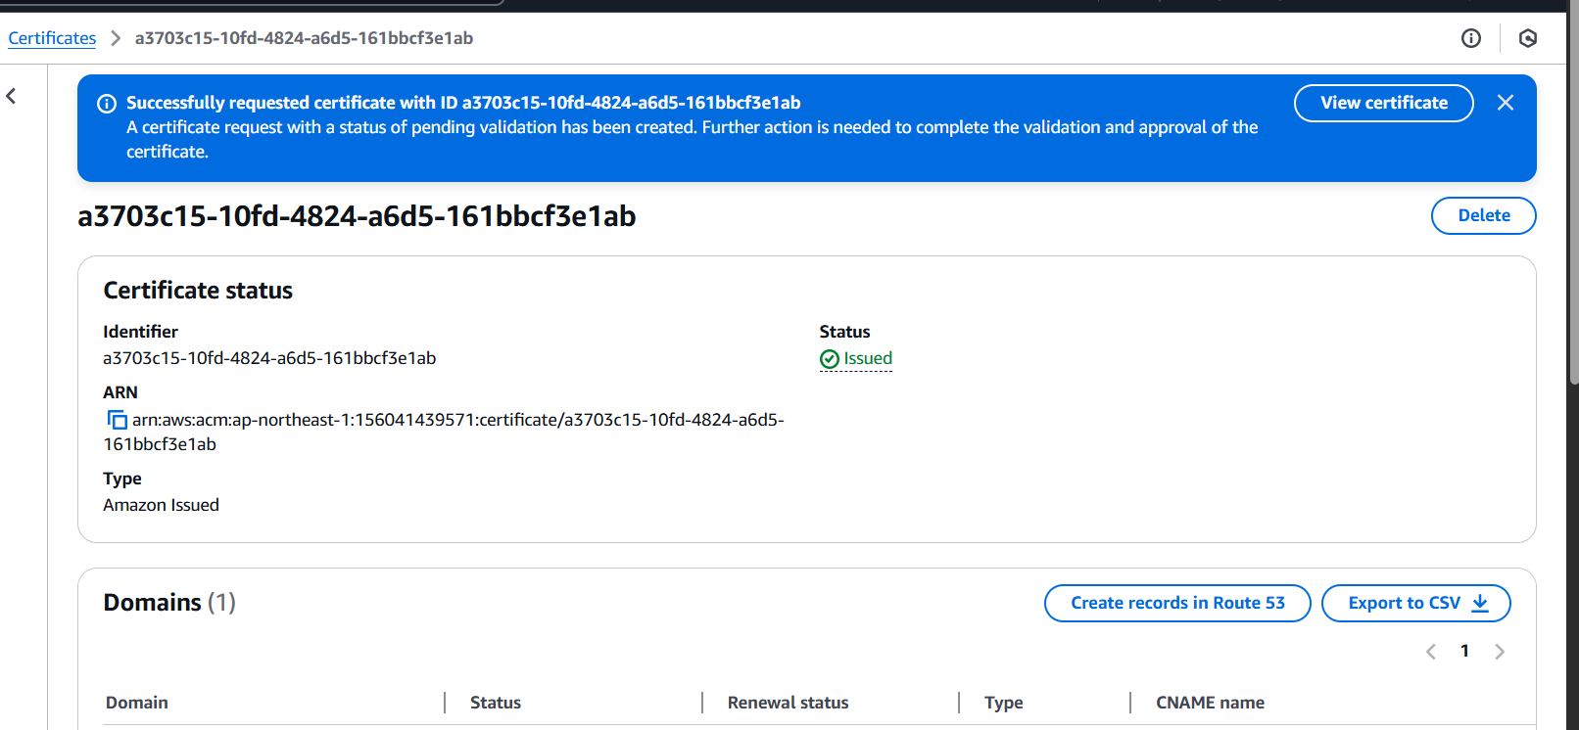

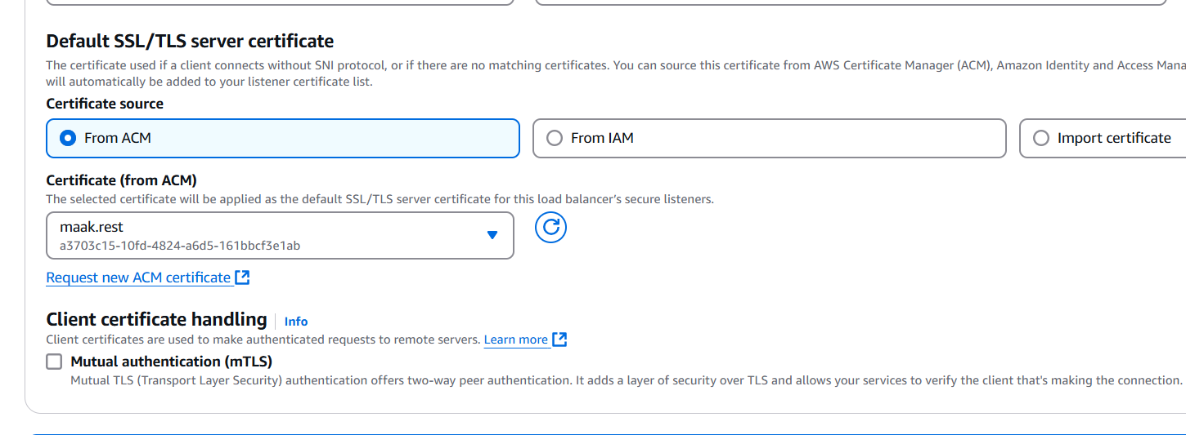
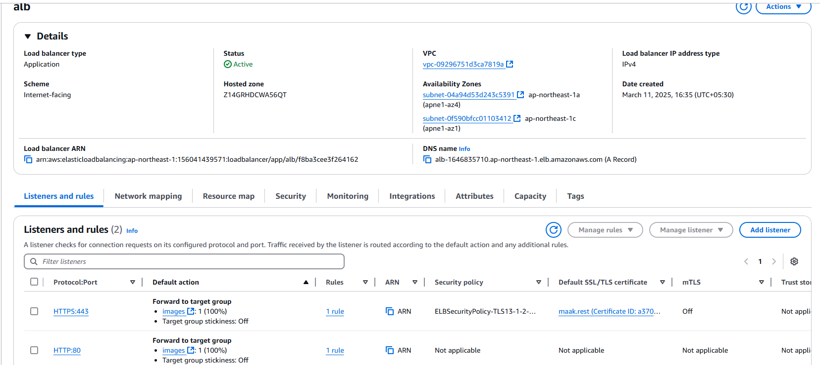
- Map Applciation load balancer to R53.*

Step 1 Step1: Mapped Application load balancer to R53
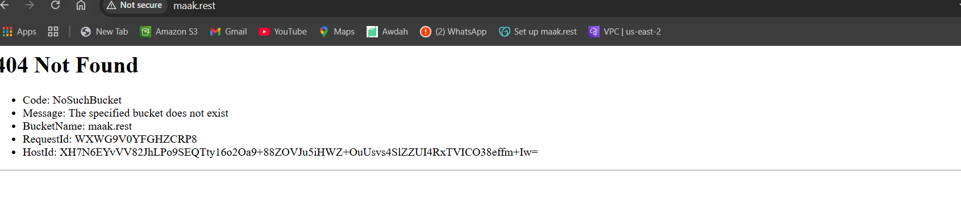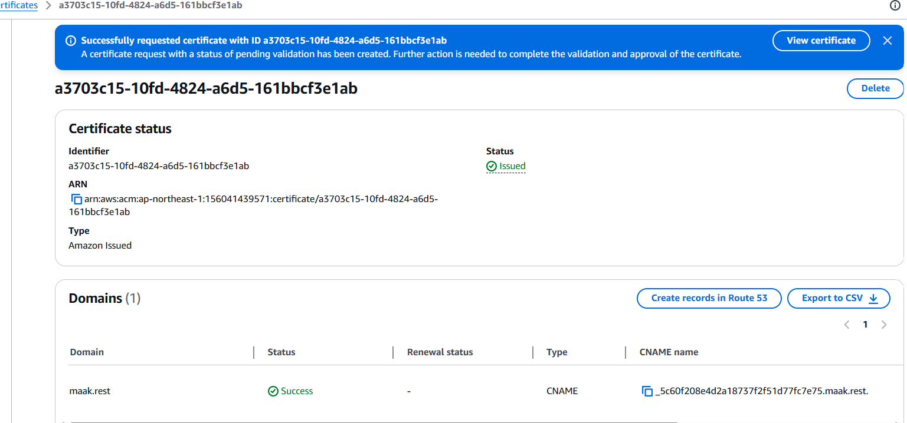
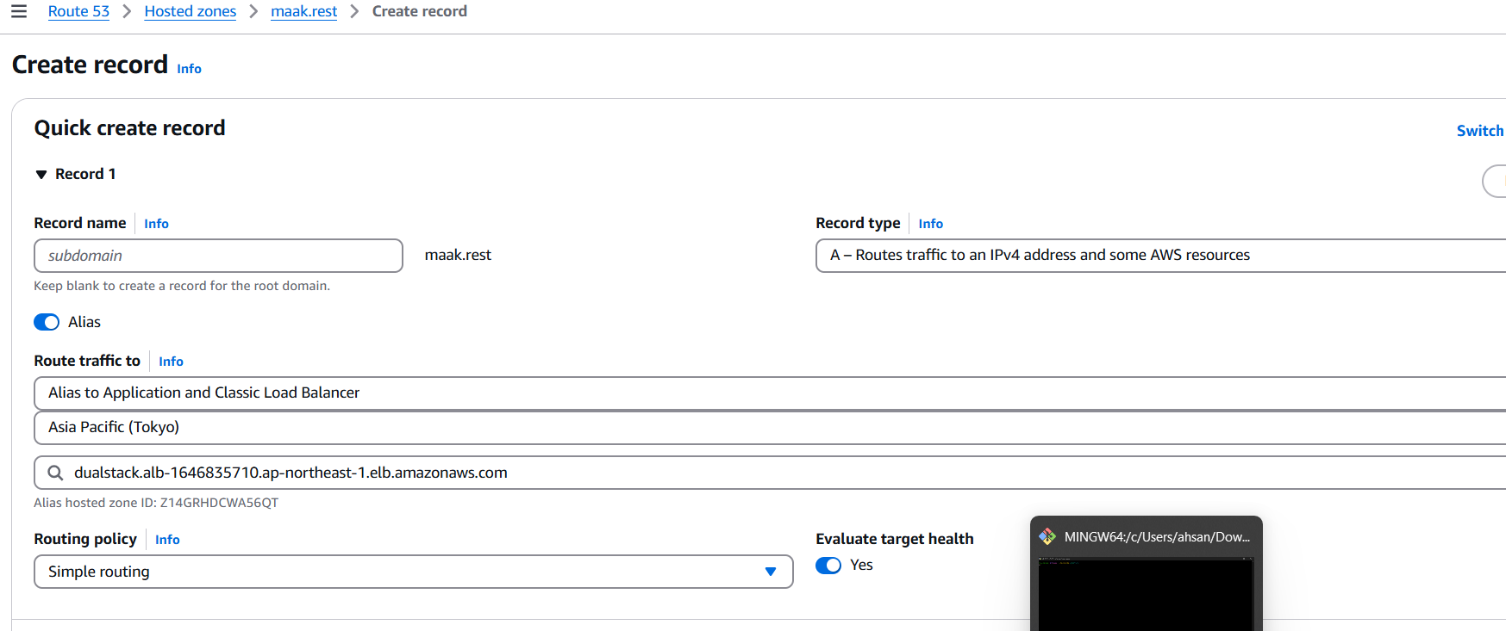
6) Push the application load balancer logs to s3.*

